Jonathan Quang 5/11/15

1WW

Approximations in Calculus

Legend says that basic calculus was discovered in a day by Sir Isaac Newton. While this legend is obviously untrue, the legend illustrates the simplicity of “discovering” calculus with basic integers.

Originally, the very beginning of calculus was finding the slope of a curve at a specific point. This proves a challenge as two points are used to determine a line. Finding the slope given an x-coordinate and a function is what this question boils down to. To solve this, two points on the curve should be selected. As the first point, called point A, has a point B move closer to point A on a graphed function, the slope of the two points seems to converge on a number. The point where the two points become just point A will determine the slope of a single point. Consider the most basic curve on a Cartesian plane, y=x2. Now imagine point A is at (3,9) on the line. For point B, select (6,36). The slope between A and B is now 9. For point B, select point (5,25) on the parabola. Now the slope between these two points would be 8. If point B was at (4,16), the slope would be 7. The slope only decreases by 1 as the x coordinate decreases by 1 on the parabola. However, no integer exists between a 3 and 4, so one might start approximating with decimals. Setting point B as (3.5, 12.25) , the slope is now 6.5. If point B is (3.01, 9.0601). the slope is 6.01. Someone could assume that the slope is 6. He or she would not be wrong. The slope of any point on y=x2 is actually twice the value of x.

Actually proving that the slope of a coordinate on y=x2 is similar to the process above, just with algebra. The slope of point A and B of these points is generally represented by the slope formula $\frac{∆y}{∆x}$ or the change in y over the change in x. Give point A the coordinates (x,y), then coordinates of point B must be (x+ $∆x$, y + $∆y$). Since y= x2, it can also be said that the y coordinate of point A is (x, x2) and (x+ , (x+2). Substitute these values into the slope formula, and the result is $\frac{{\left(x+∆x\right)}^{2} -x^{2}}{∆x}$. Expanding the numerator results in $\frac{x^{2}+2x∆x+ x∆^{2}-x^{2}}{∆x}$, which simplifies to $\frac{2x∆x+ x∆^{2}}{∆x}$, and then simplifies further into the slope being $2x+ x∆$. As with the problem in the paragraph above, the slope of a single point means that there is no change in the x coordinate. If x $∆$ = 0, then the slope of a point is simply 2x + 0, or just 2x.

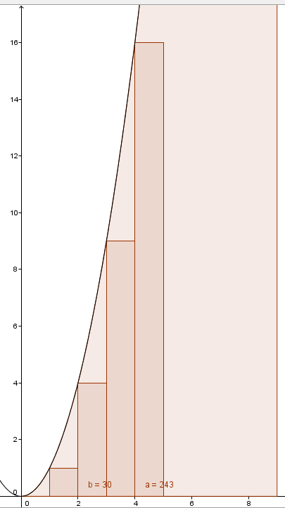 Newton started with the problem of derivatives, Gottfried Wilhelm Leibniz was also working on the concept of integrals, albeit they worked in calculus in general . The basic problem of integrals is the area of the space under a curved function, generally sticking to the first quadrant of the Cartesian plane. Approximating the area under y=x2 can be done with rectangles with a width of 1. The first rectangle has a width of 1, and a height of 1. The second rectangle is at an x coordinate of 2, and thus has a width of 1 but a height of 22=4. For the third rectangle at an x coordinate, the height is 32=9. The height of a rectangle multiplied by its width would mean that the area of each rectangle is its x-coordinate squared. As a result, the approximate area under the curve can be found as consecutive sum of squares. Say we want to find the sum of squares up to x=5. This is just 12+22+32+42+52 =1+4+9+16+25=55, so we can say that the area of the curve y=x2 from the origin to x=5 is about 55. Say we want to calculate up to x=50. This is a ridiculous task for a human, with the sum of squares being 42925. , The sum of squares can be represented in general by or 12+22+32+42+52…n2, which in this case would be 12+22+32+42+52…502

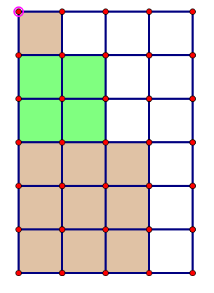Finding the sum of squares requires understanding that the sum of a sequence of integers starting from 1 to n is $\frac{n(n+1)}{2}$. Finding a formula for the sum of squares is slightly more complicated than this. Generally, using three dimensional graphics to derive the sum of squares is used, but there is a graphically simpler way.

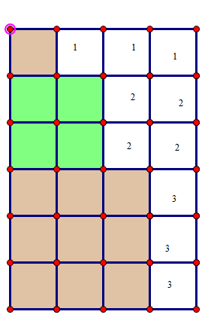If one draws squares with the next square placed under it with a side length equal to the term length in the sequence, the colored squares in the picture above are created. Instead of drawing this up to 50, it would be faster to figure out a relationship between a rectangle containing the sum of squares and the sum of squares. If a rectangle is created where the width is one more than the side length of the largest square and with a length equal to the combined lengths of all squares, then the rectangle's area can be represented as (n+1)(the sum of all positive integers to the nth term). Since the sum of all positive integers up to the nth term is $\frac{n(n+1)}{2}$, the area of the rectangle is (n+1) $(\frac{n(n+1)}{2})$. Logically speaking, subtracting the amount of uncolored squares from the area of the rectangle should yield the sum of squares, meaning $\sum_{n=1}^{∞}{n^{2}}$ = the uncolored area subtracted from (n+1) $(\frac{n(n+1)}{2})$. In the picture on the right, the uncolored area is composed of sum of positive integers. One could say that the uncolored area is (1+2+3)+(1+2)+1 and the area of the rectangle is (3+1)(1+2+3). This makes the sum of squares up to the third term. (3+1)(1+2+3) - (1+2+3)+(1+2)+1, which equals 14. This way of calculating the sum of squares is certainly helpful since the sum of positive integers can be substituted in. The problem here is using the sum of positive integers to express the area of the uncolored area. The uncolored area is the sum of the sum of positive integers to the first term + the sum of positive integers to the second term all the way to the sum of positive integers of the nth term. This can be represented as $\sum_{i=1}^{n}{(\sum_{j=1}^{n}{i})}$. Overall, the sum of squares can be represented by $\sum_{n=1}^{n}{n^{2}}$ =(n+1) $(\frac{n(n+1)}{2})$- $\sum_{i=1}^{n}{(\sum_{i=1}^{n}{i})}$.

If we substitute into the righter most sigma notation the formula for the sum of positive integers, then the equation is now $\sum_{n=1}^{n}{n^{2}}$ =(n+1) $(\frac{n(n+1)}{2})$- $\sum_{i=1}^{n}{(\frac{i(i+1)}{2})}$. Say we multiply both sides of the equation by 2 to get rid of the fractions, the result is $2(\sum_{n=1}^{∞}{n^{2})}$ =(n+1) $(n(n+1))$- $\sum_{i=1}^{n}{(i(i+1)}$). Now, here is the creative part. If we multiply out the last two terms, the result is $2(\sum_{n=1}^{∞}{n^{2})}$ =(n+1) $(n(n+1))$- $\sum_{i=1}^{n}{(i^{2}}+i$). $\sum_{i=1}^{n}{(i^{2}}+i$) is another way of saying that the sum of consecutive positive integers squared plus the sum of consecutive positive integers. If we substitute in the summation notation for the sum of squares and the sum of consecutive positive integers formula, the result is $2(\sum_{n=1}^{∞}{n^{2})}$ =(n+1) $(n(n+1))$- $\sum_{n=1}^{∞}{n^{2}}$- $\frac{n(n+1)}{2}$. If we add $\sum_{n=1}^{∞}{n^{2}}$ to both sides, the result is $3(\sum_{n=1}^{∞}{n^{2})}$ =(n+1) $(n(n+1))$- $\frac{n(n+1)}{2}$. Now we multiply out the right sides of the equation to get = n3+2n2+n - . This all boils down to =n3 + . Dividing both sides by 3 yields the sum of consecutive positive squares, $(\sum_{n=1}^{∞}{n^{2})}=\frac{n^{3}}{3}+\frac{n^{2}}{2} + \frac{n}{6}$. This simplifies to the more popular format of $\sum_{n=1}^{∞}{n^{2}}=\frac{{2n}^{3}+3n^{2}+n}{6}$. If 50 is plugged into this equation, the result is 42925. To ensure that this equation works with other numbers, if 5 is plugged into the equation, the result is 55.

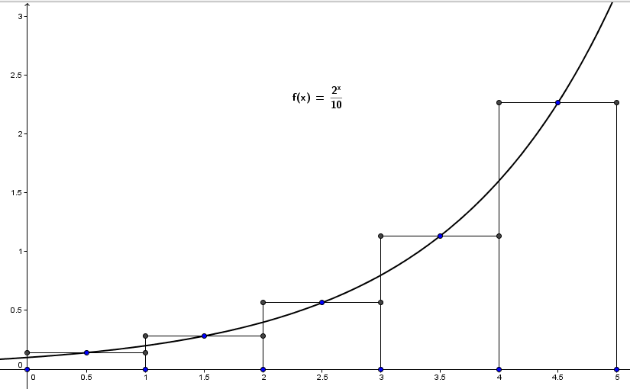 This is nice and all, but this only concerns the parabola y = x2. Integrals are used to find the area under the curve of functions in general consider the equation f(x)= $\frac{2^{x}}{10}$. If rectangles are drawn with the base of 1 and a height where the midpoint of the top base meets the line of the function, then we can approximate the area under this curve as shown to the right. To approximate with this, a method similar to deriving the derivative can be used, which is using Δx to find a value and make Δx smaller. The integral notation, $\int_{a}^{b}{\frac{2^{x}}{10}}$, states that between the interval [a,b], it is divided into n sections of equal width. Δx= $\frac{b-a}{n}$. In this example, $\int_{0}^{5}{\frac{2^{x}}{10}}$ will be calculated. Each section or interval can be expressed as [x0,x1], [x1,x2],…,[x4,x5]. The rectangle’s height is the y coordinate where the midpoint’s x coordinate lies on the function. The rectangles formed in each section can be expressed as x1\* for the first section, x2\*for the second section and so on. Since the height of each rectangle is f(x) of x, the height of the first section would be f(x1\*). It can be said that = Δx\* f(x1\*)+ Δx\* f(x2\*)… Δx\* f(x5\*) with Δx representing the width of each rectangle and f(xn\*) representing the height. Factoring out the Δx results in the general midpoint rule applied to this equation:= Δx[f(x1\*)+ f(x2\*)+ … f(x5\*)]. Since Δx is 1 in this case, the approximation is just the sum of the f(x) parts, which is 4.38406204335659.

F(x)=(2x/10)

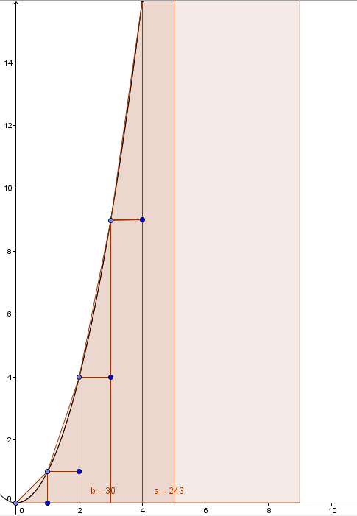 With the sum of squares problem with y=x2, you may have realized that if a right triangle is added to the top of each rectangle, then the approximation of the curve underneath must be more accurate. The base of each triangle is still one. The height of each triangle is the difference between one squared number and the next squared number. The difference between 02 and 12 is still one. The difference between 12 and 22  is 3. Between 22  and 32  is 5. The difference between 32  and 42  is 7. The difference between consecutive squares is always the next odd number. Take 32 and 42, they can be expressed as (3+1)2 – 32. Expanding the binomial results in 32 +2\*3+1 - 32. The result is 2\*3+1. Two multiplied by any number will result in an even number, which when one is added, will result in an odd number ( [n+1]2 –n2)= 2n+1). The area of the triangles is now the sum of odd numbers divided by . Conversely, the sum of odd numbers will result in perfect squares (1=1, 1+3=4, 4+5=9…). The sum of the areas of the triangles up to the nth number is just $\frac{n^{2}}{2}$. If this formula is added to the sum of squares approximation in the previous page, a better approximation for the area under a curve is now $\frac{{2n}^{3}+3n^{2}+n}{6}$ + $\frac{n^{2}}{2}$ = $\frac{{2n}^{3}+3n^{2}+n}{6}$ + $\frac{{3n}^{2}}{6}$ = $\frac{{2n}^{3}+6n^{2}+n}{6}$. The area under y=x2 between 0 and 4 is now about 30 + 8 instead of just 38.

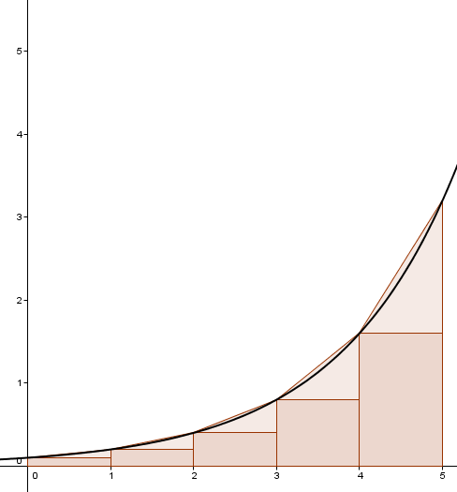 A right triangle on top of a rectangle like this is technically just a trapezoid. A trapezoid can be used to provide an approximation more accurately than a rectangle, but only in some cases. Refer back to the equation f(x)= $\frac{2^{x}}{10}$. We can see that the base of each trapezoid is f(x) of one coordinate and f(x) of the next x coordinate, and the height is x. The height of each trapezoid can be defined by the change in x or Δx, which is once again the higher x coordinate minus the smaller x coordinate over the number of trapezoids. For this example, 0 to 5 will be the x coordinates and it shall be divided into 5 trapezoids of equal height, which means that Δx will be 1. The area of the first trapezoid would be $\frac{Δx [f(x0) + f(x1) }{2}$. The next trapezoid is $\frac{Δx [f(x1) + f(x2) }{2}$, followed by $\frac{Δx [f(x2) + f(x3) }{2}$ all the way up to $\frac{Δx [f(x4) + f(x5) }{2}$. We can factor out $\frac{Δx }{2}$ from the sum of areas, resulting in $\frac{Δx }{2}$ [f +) + ) +) +). Notice that only the first and last function of x's are not used twice. This means that the sum of areas of trapezoids can be further simplified to $\frac{Δx }{2}$ (f $(x0) + 2(f\left(x1\right))$ + $2(f\left(x2\right))$ + $2(f\left(x3\right))$ + $2(f\left(x4\right))$ + $(f\left(x5\right))$ where Δx/2 is equal to 1. This results of an area of about 4.65 under the equation. Say for the same space, ten trapezoids should be used. A space of 5 divided into 10 sections means that the Δx is 1/2, there are 10 intervals for which f(x) should be applied, and that Δx is 1/4, and resulting in an area of   
about 4.517.

Naturally, after using right angled polygons, using a line not angled at 90o, what comes after is using parabolas to approximate the area. This is called Simpson's rule. However, Simpson's rule cannot be used without knowing beforehand the area under a parabola, which will end up in a proof of the area under any function. Say that the integral of f(x) was to be found. In calculus, it is known that the integral of f(x) is equal to function F whose derivative itself is f(x). There are numerous explanations for this.

http://tutorial.math.lamar.edu/Classes/CalcII/ApproximatingDefIntegrals.aspx